- Introduction
Node.js is a JavaScript runtime built on Google’s V8 engine.
It allows JavaScript to run outside the browser.
Designed for scalable, fast, I/O-heavy applications (e.g., APIs, real-time apps).

- Key Features
✔ Asynchronous & Non-Blocking I/O
Node uses an event-driven architecture.
Long operations (DB calls, file read) run in the background.
Improves performance for high-traffic servers.
✔ Single Threaded
A single main thread handles incoming requests.
Heavy CPU tasks should be avoided.
✔ Event Loop
Core mechanism that handles callbacks, timers, promises, I/O events.
✔ NPM – Node Package Manager
Largest ecosystem of open-source libraries.

- Node.js Advantages
  - Fast Performance (Powered by V8 Engine)

Node.js uses Google’s V8 JavaScript engine, which compiles JS into machine code, resulting in:
Very fast execution
High throughput
Efficient handling of large numbers of operations

  - Non-blocking, Event-Driven Architecture

Node.js uses a single-threaded event loop, allowing it to handle:
Thousands of concurrent connections
Without creating multiple threads
This makes it ideal for:
Real-time applications
I/O-heavy apps (APIs, streaming, chat apps)

  - JavaScript Everywhere

Developers can use JavaScript for both frontend and backend, reducing the need to learn multiple languages.
This means:
Faster development
Easier hiring
Better code sharing

  - Huge Ecosystem (npm)

Node.js has one of the largest package ecosystems in the world.
Benefits:
Ready-made libraries for almost anything
Faster prototyping
Active community support

  - Lightweight and Efficient:
Because of asynchronous programming and no thread blocking, Node.js applications:
Use fewer system resources
Are efficient under load

  - Easy to Learn (if you know JavaScript)
Frontend developers can quickly switch to backend development, making Node something you can adopt fast.

- Node.js Limitations
  - Not Good for CPU-Intensive Tasks:
Node.js runs on a single thread.Heavy tasks like:
- Image processing
- Video encoding
- Complex calculations
- Machine learning
…can block the event loop and slow down the entire application.
  - Callback Hell (Though Improved with Promises/Async-Await)
Node.js originally relied heavily on callbacks.
Complex nested callbacks lead to:
Hard-to-read code
Difficult debugging
Increased bugs
Modern JS helps, but older codebases still suffer.

  - Asynchronous Programming Is Hard for Some Developers
Writing async code efficiently requires:
Understanding Promises
Error handling with async/await
Managing concurrency

- Node.js Modules
Node uses the CommonJS module system:
CommonJS was introduced in 2009, Kevin Dangoor as an effort to create a standardized module system for JavaScript outside the browser. Shortly after, Node.js adopted CommonJS, making it the default module system for server-side JavaScript.
CommonJS modules are synchronous, meaning they execute and load files in a blocking manner. This approach works well in server environments where files are loaded from the local filesystem but can become problematic in browsers, where asynchronous execution is preferred.
The following are some of the key features of CommonJS:
- Uses require() to import modules.
- Uses module.exports or exports to export functions, objects, or variables.
- Supports caching of required modules.

Here’s how you can export a function using CommonJS with module.exports:
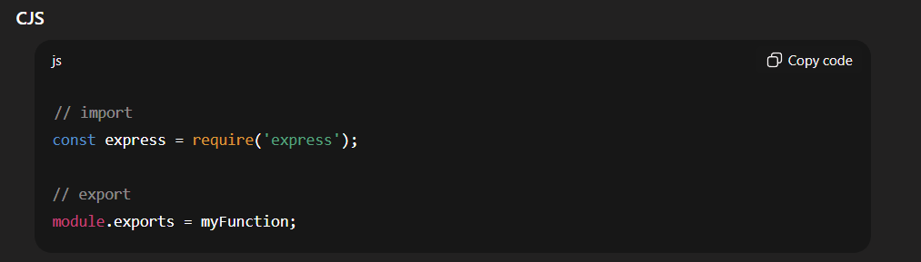

ECMAScript modules were introduced in ES6 (2015) as the official JavaScript module system. Unlike CommonJS, ESM is designed for both browsers and servers, providing a unified standard for JavaScript modularity.

The following are some of the key features of ESM:
- Uses import and export instead of require() and module.exports.
- Enables static analysis, allowing tree shaking (removal of unused code).
- Supports top-level await - Requires explicit file extensions in relative imports (.mjs, .js, or .cjs).
To use ESM in Node.js, update package.json by adding "type": "module". This ensures that .js files are treated as ES modules. If you prefer not to modify the project-wide setting, rename files to .mjs instead.

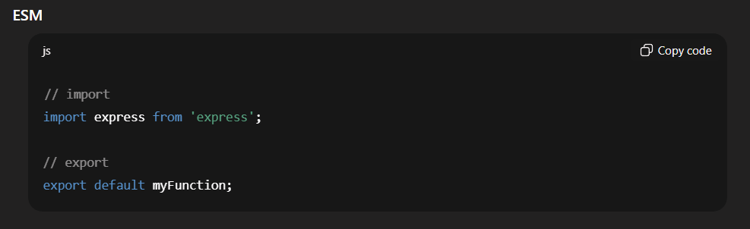

6.FS Modules (sync)
- The fs module in Nde.js is a core module that allows you to work with file system , enabling you to read , write , update , delete and watch files .

- Express.js
Express is a web application framework for Node.js.
It helps you build server-side applications, REST APIs, and handle things like:
- Routing (URLs → functions)
- Handling HTTP requests (GET, POST, etc.)
- Sending responses (HTML, JSON, files)
- Middleware (auth, logging, parsing data)
- Integration with databases

- What is middleware ?
Middleware in Node.js (specifically in Express) is a function that runs between the request and the response.
Middleware is a function that has access to req, res, and next objects and executes before the final response.

➡️ When a user sends a request to the server, before sending the response, middleware can:
✔ Check authentication
✔ Parse data (JSON / form)
✔ Log information
✔ Validate input
✔ Modify request/response objects
✔ Handle errors

For the application:
Create firstly backend and frontend folder then in backend use the command
npm init -y
it creates the package.json file in backend then move it to the next step
npm i express
it will creates the node_modules file and package-lock.json

- For creating server :
Nextly create one server.js file in backend for creating a server . following are the structure :

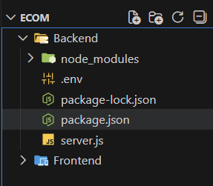

In server.js create server with protected port :

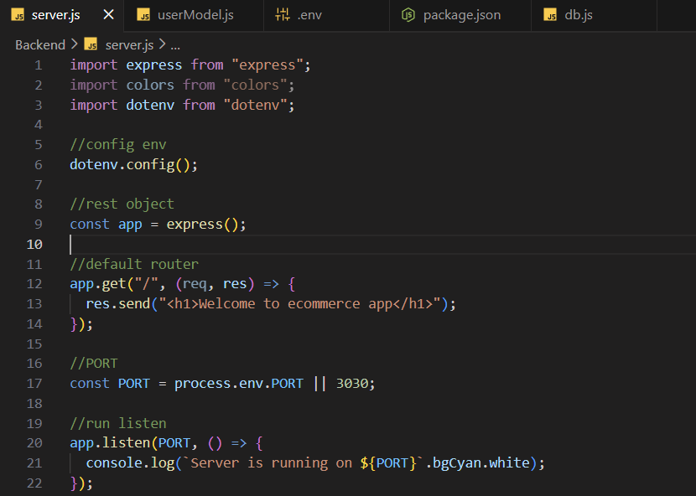

For installing .env => npm i dotenv is the command

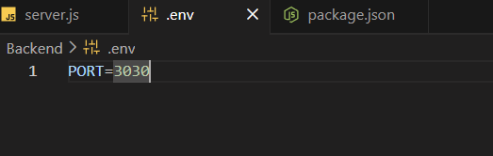

Package.json format:

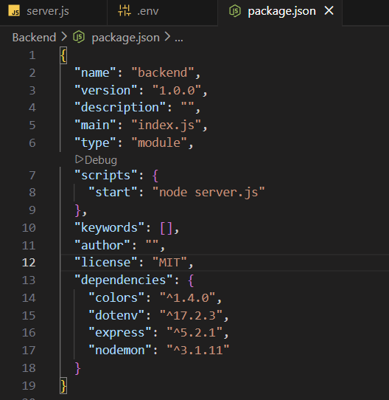
Add type as a module and also change the script to start as a node server.js

For run the server open command prompt and run npm start

Node.js by default does not auto-restart the server.
You must stop (Ctrl + C) and run again to see the changes. For that you can use the nodemon
Command: npm i -g nodemon
Then add script in package.json

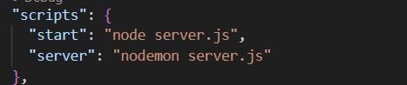
Run server with command npm run server

- For database connectivity:
Create one folder name as a config in that create db.js file for database
In .env file create one string as MONGO_URI = your connection string.
Use the cluster for database so you can deploy your project in future if you use local database you can’t deploy your project as live . For creating database you can use MongoDB Atlas cluster signIn to MongoDB Atlas create cluster for a free add IP Address then you can connect it as compass if you have already installed MongoDB compass in your system
Copy the string of your database for connectivity or you can use your cluster in your MongoDB compass for long time support

e.g.
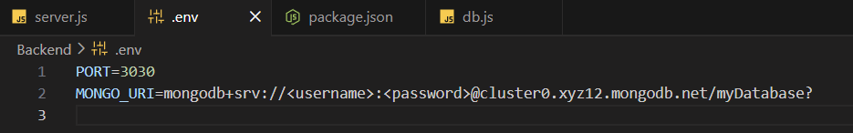

db.js : install mongoose with npm i mongoose

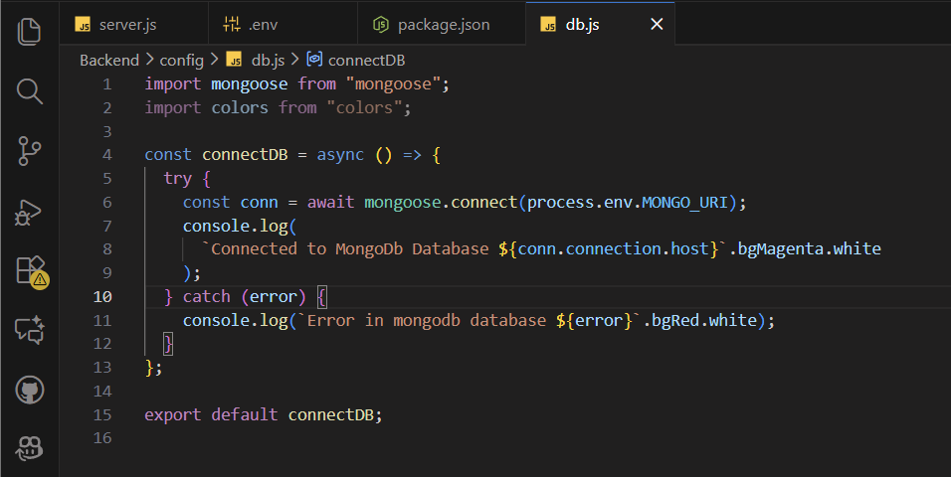

Then in server.js connect our database

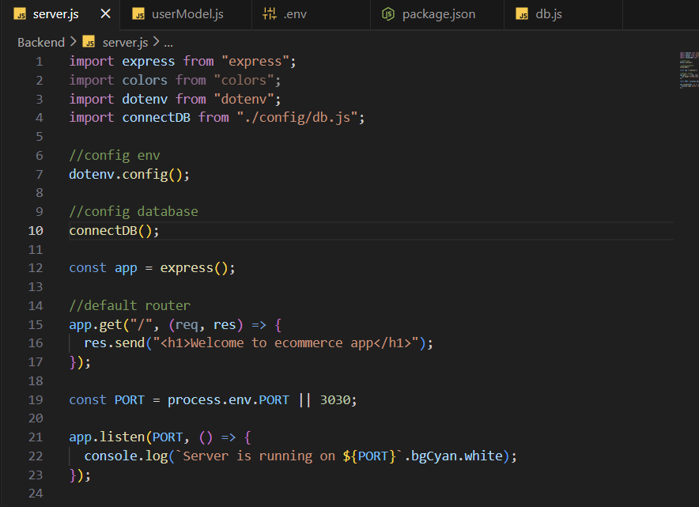

📌 What is a Model?
A Model is a structure that represents a collection in the database.
It defines how data will be stored (fields, types, validations)
Create models folder in Backend in that create userModels.js
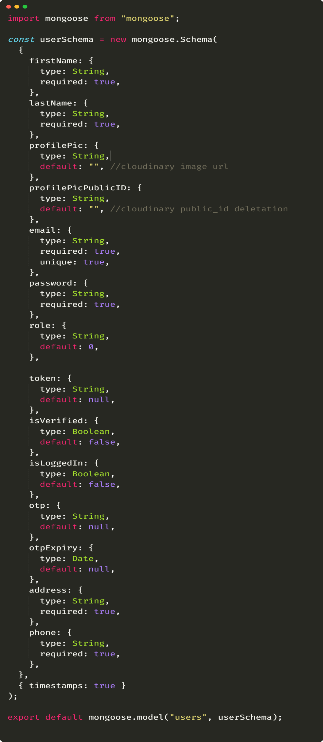
Then create routes folder in that create userRoute.js
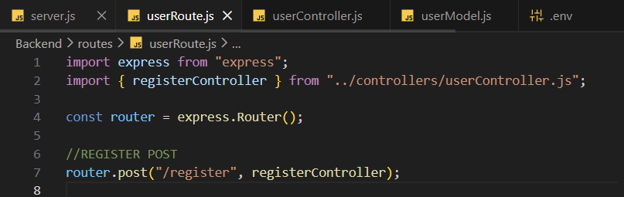
Then add the route in our main page means in the server.js and also define our routes are in json format with express
.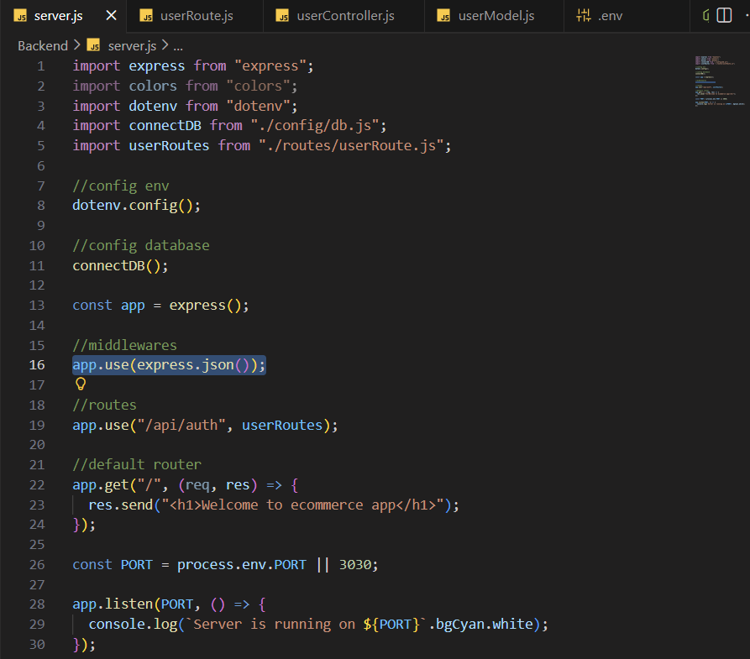
For register the user also create the controller folder in backend with userController.js where user can registered with conditions
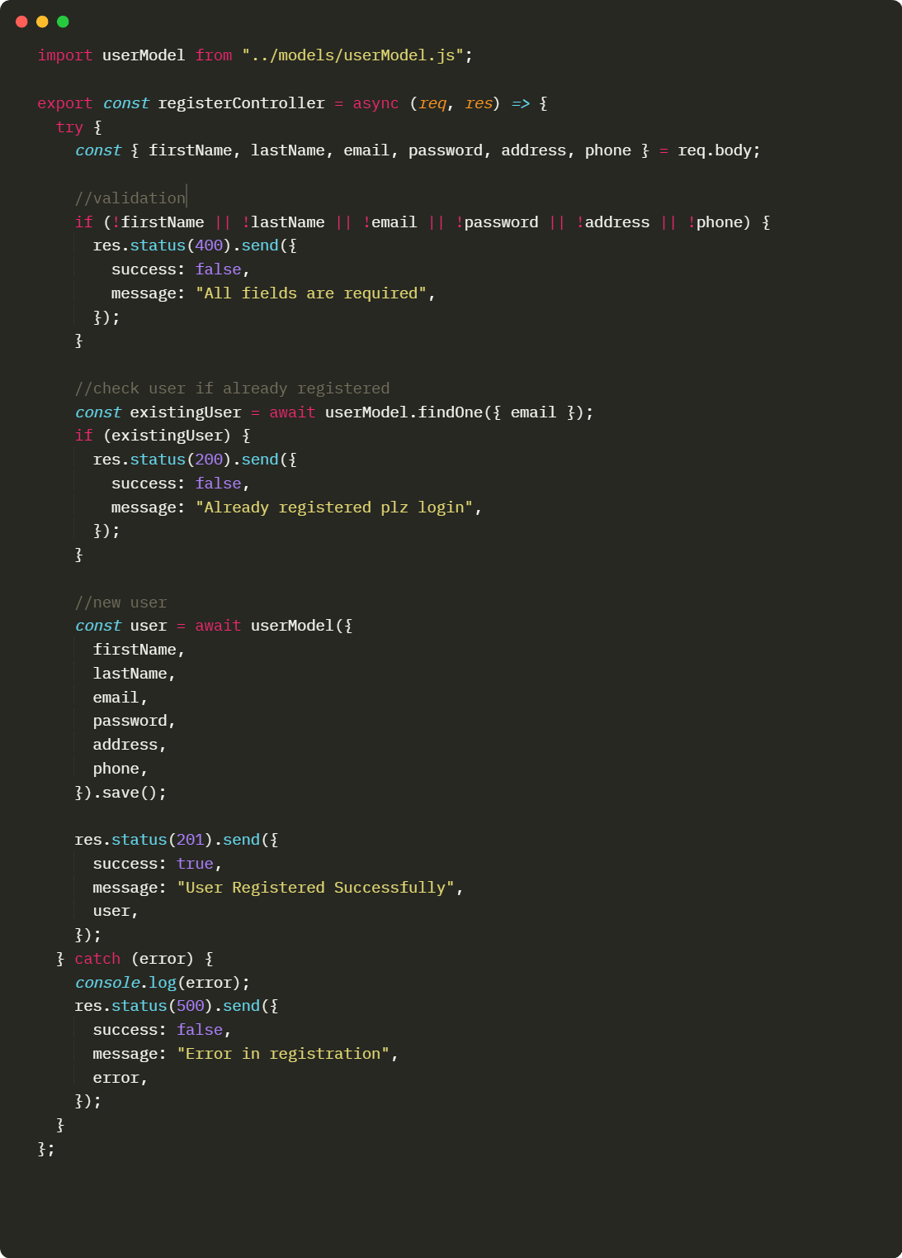
Check the route is working or not in postman
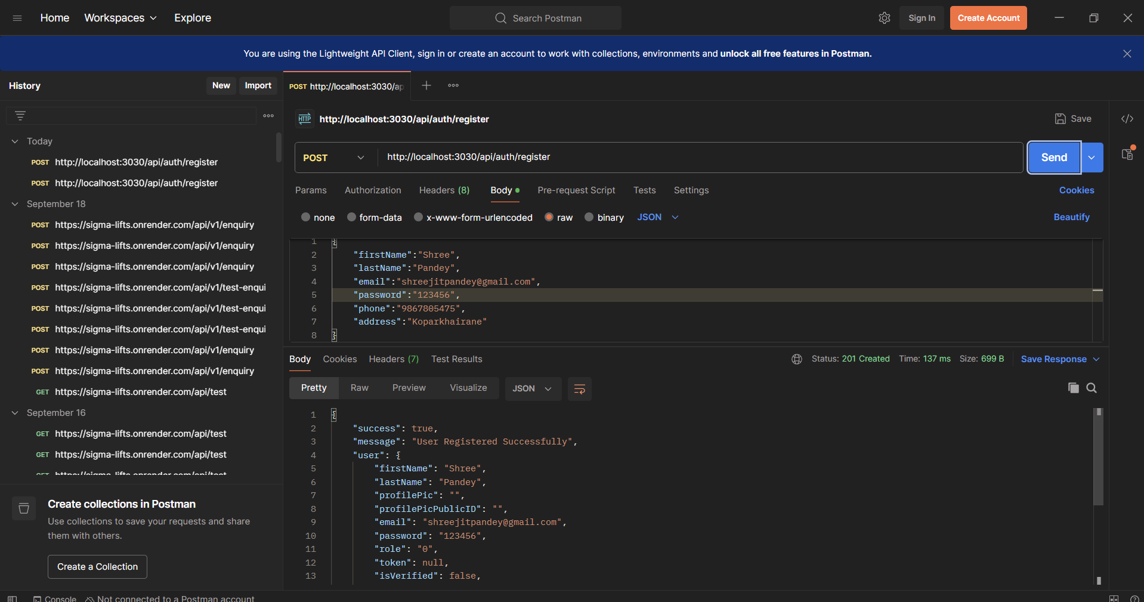

After registered the user we have to encrypt the user password for security for that install the bcrypt
Command : npm i bcrypt
Create one folder as a helpers in that create userHelper.js
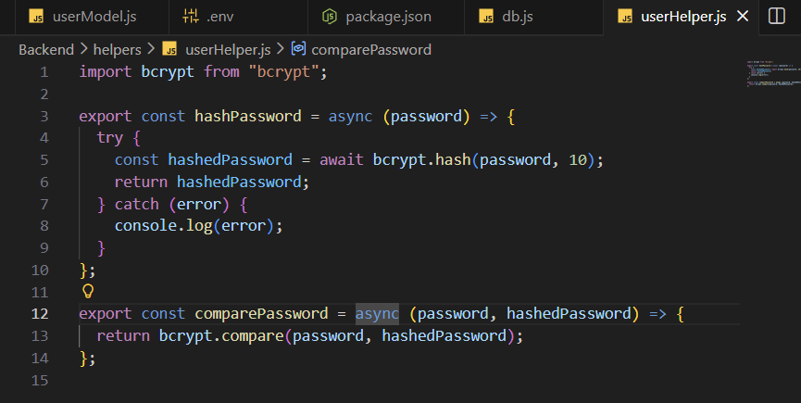

Then hashed the password in controller before creating the user
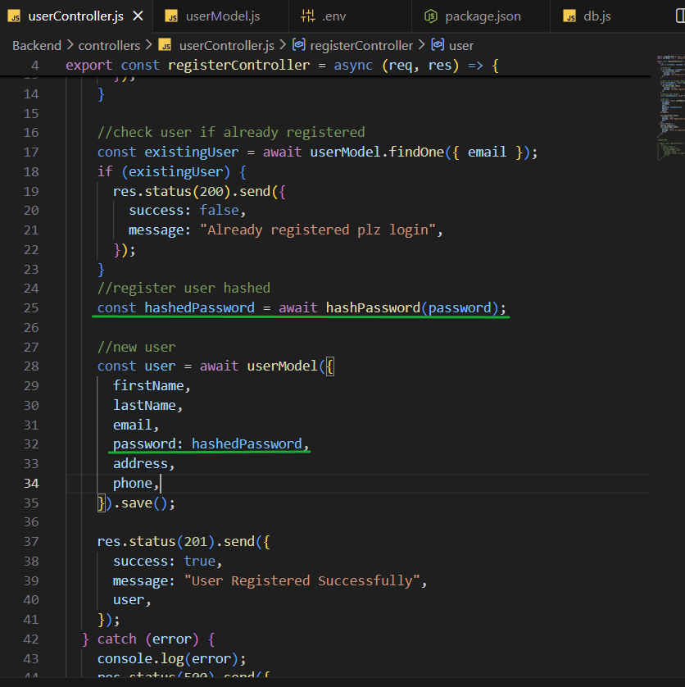

Again register the defferent user for checking the user’s password is hashed or not , like that …
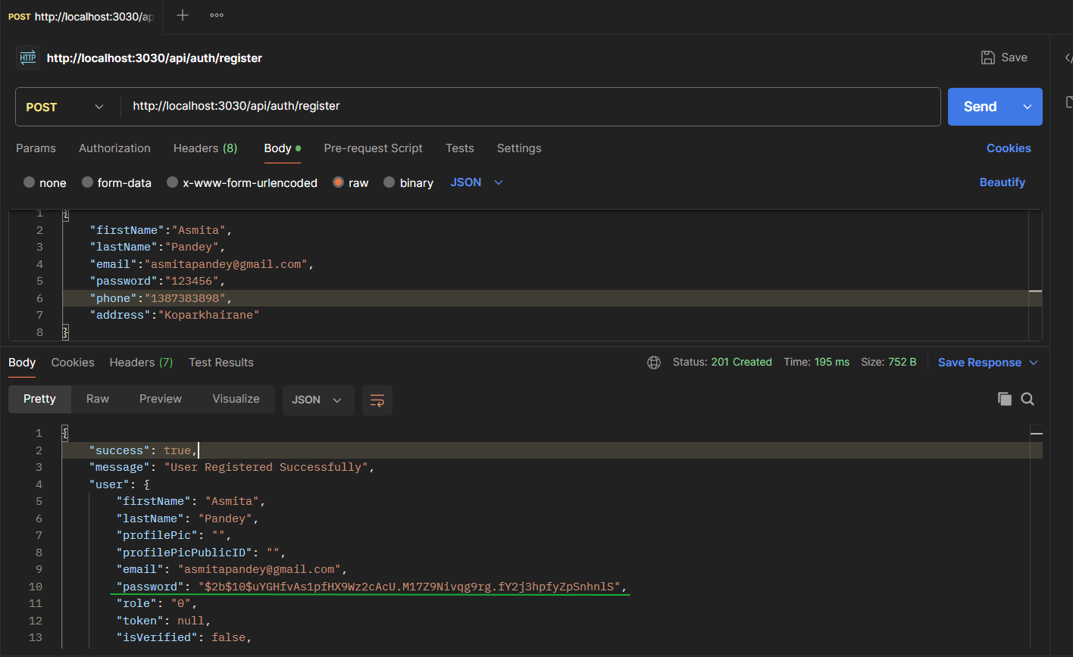
Next login the user with token install jsonwebtoken
Command : npm i jsonwebtoken
Create login route & loginController.js also create the token for login user
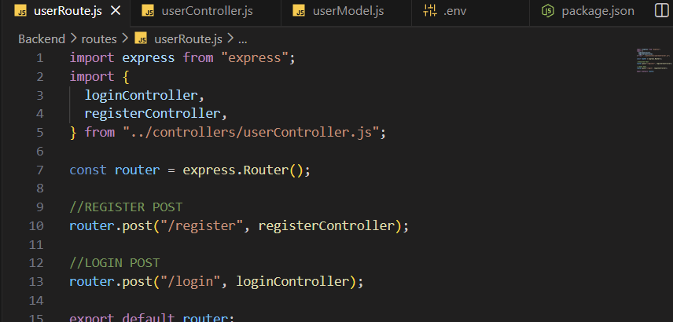
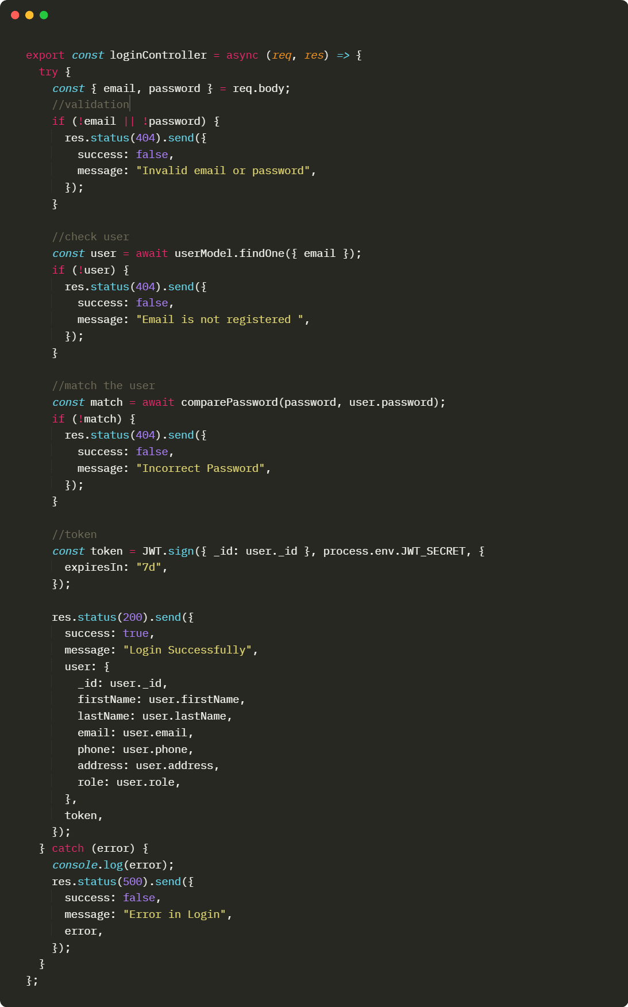
In .env file create one secret key you can put random text in it
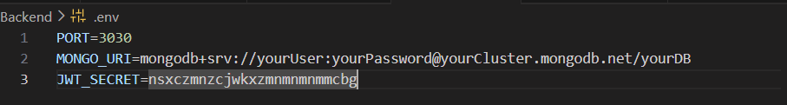
Create mail authentication with nodemailer
1st step: npm i nodemailer
2nd step: Add .env Values for pass key open google account visit security and sign-in then Turn ON 2-Step Verification Complete the verification for creating pass key click on passkeys and security keys and create your pass copy the pass and paste it to the .env file
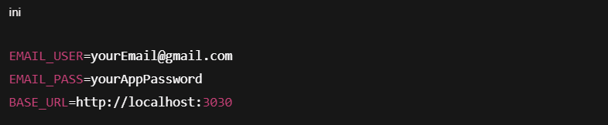
3rd step: Create a simple email sender (email.js)
Create file: helpers/emailHelper.js
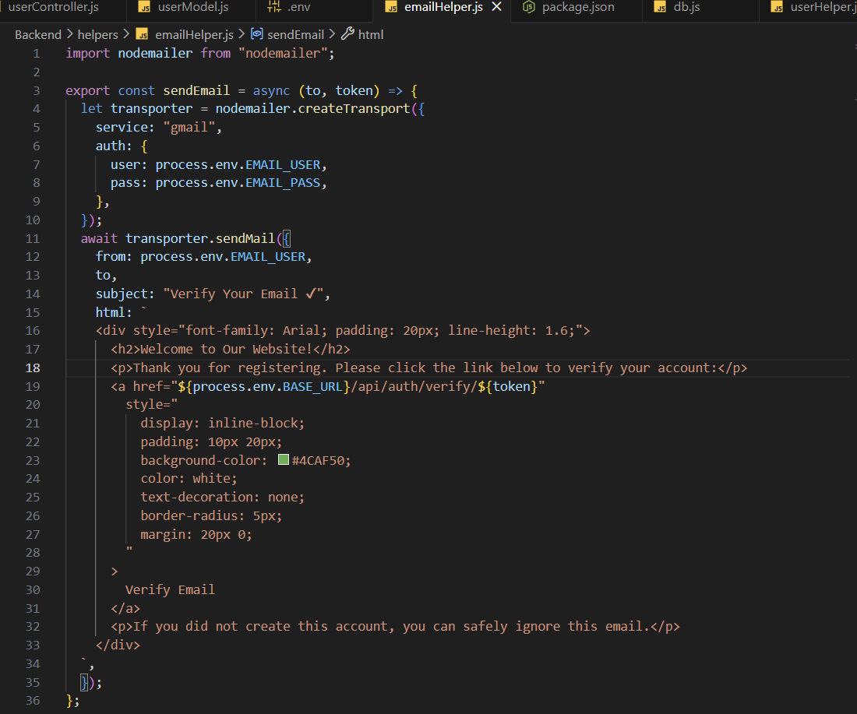
4th step: Update Register Controller
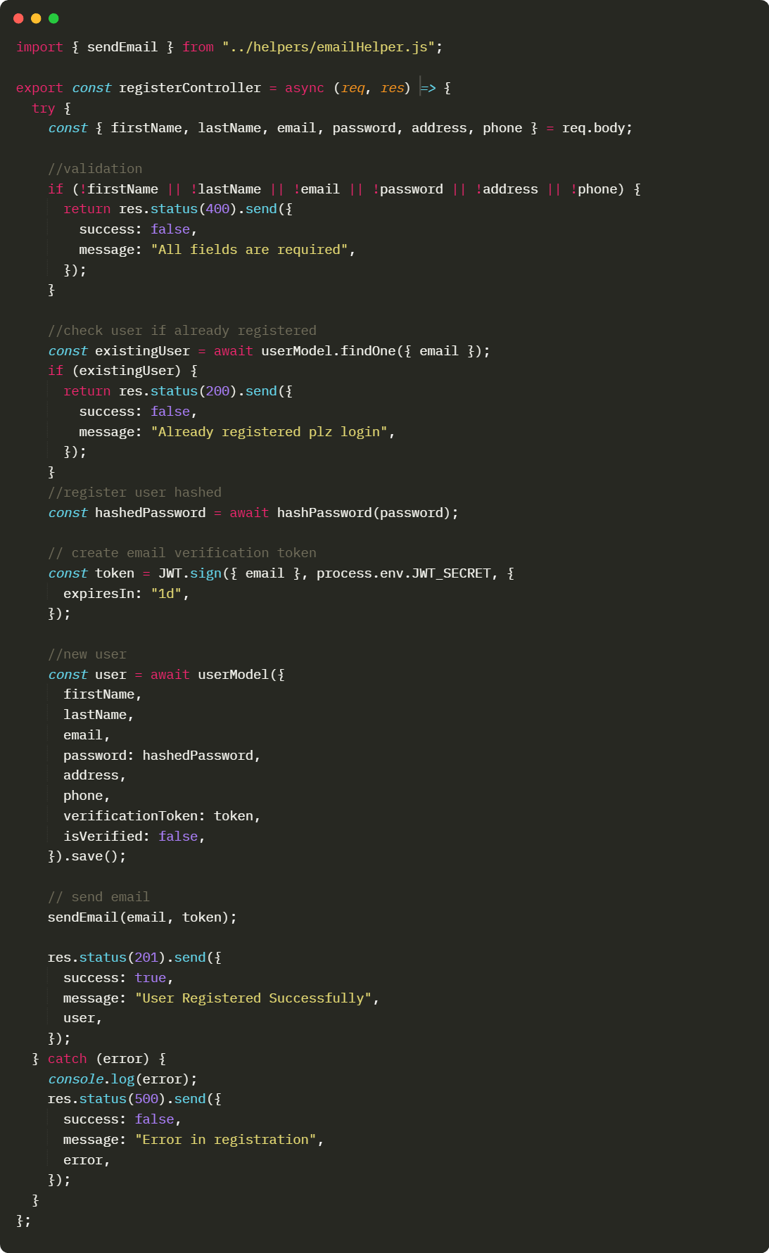
5th step: Add Verify Route
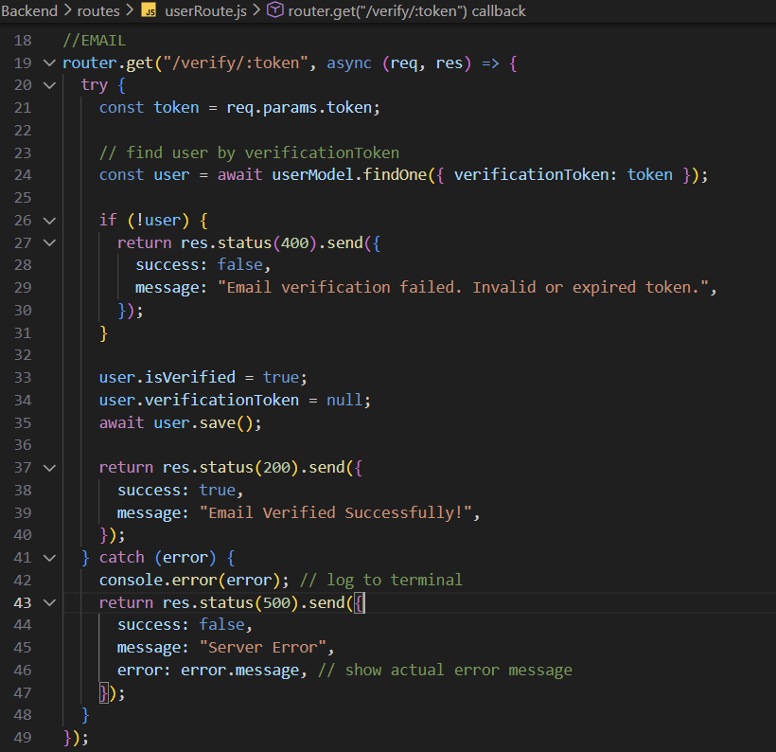
Create protected route or middleware where we can give access to the admin
What is middleware?
Middleware means a checking function.
It is a function that runs before your main route and can:
✔ Check something (like token, admin, login)
✔ Allow the request → using next()
✔ Or stop the request → send error
1st step: create middlewares folder in that add userMiddleware.js
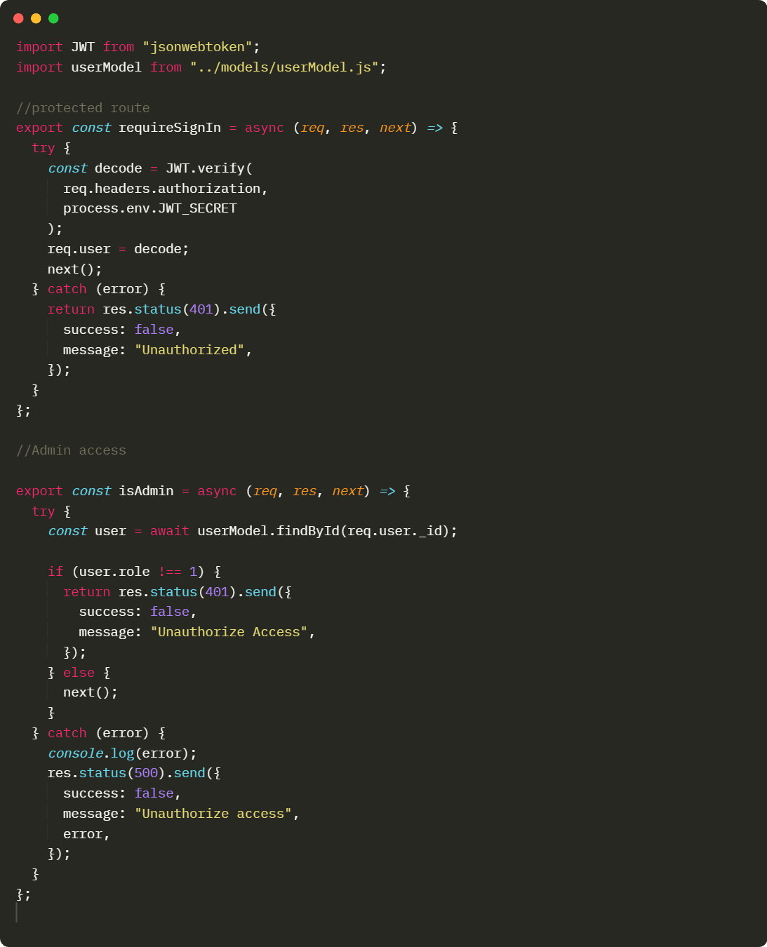

2nd step: create one route as a test
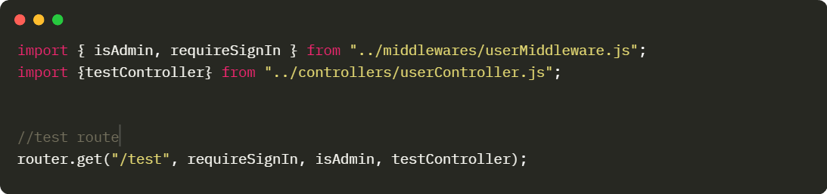

3rd step: create controller for testing the route or middleware is perfectly working or not
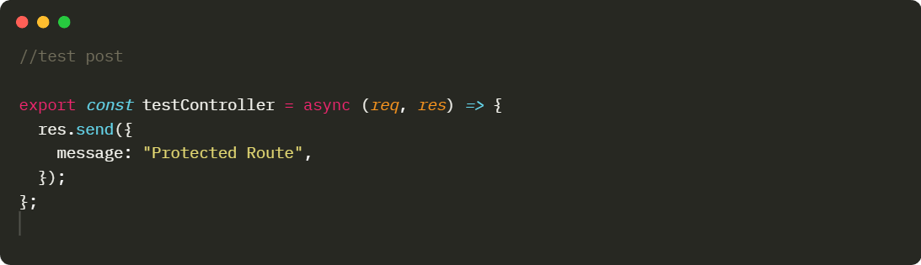
If you want to check the route is working or not following are the steps:-
1st step:
In postman send the request with get method and route will be
http://localhost:3030/api/auth/test
then in headers add keys as a Authorization and their value will be you token means we have to check after click on send it will be check token is match to the accessable user means the user’s role have the value of 1 then its shows the response as a protected route eighter it shows the error or something message
e.g. 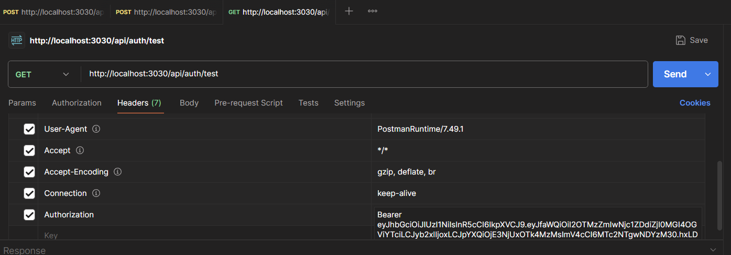
The response will be like this if user’s role have value of 1:
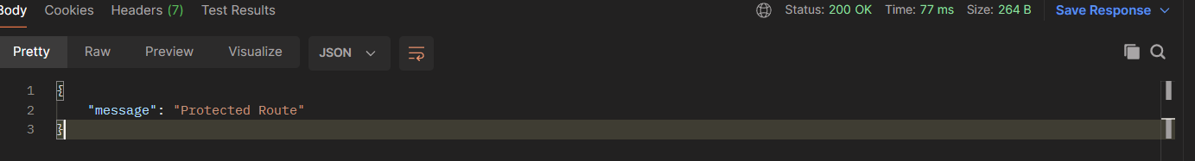
If user have 0 role then following will be the output:
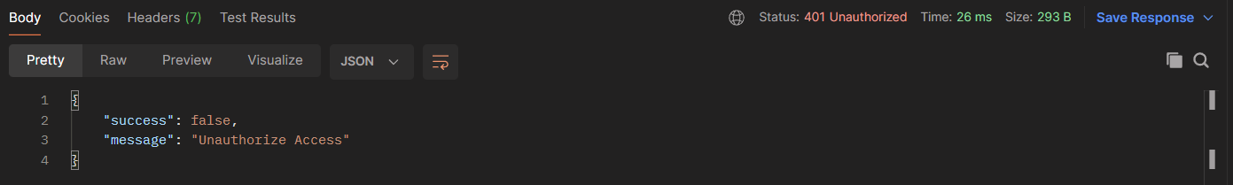
For checking the authorization you can simply change the role in MongoDB database with update option
e.g.
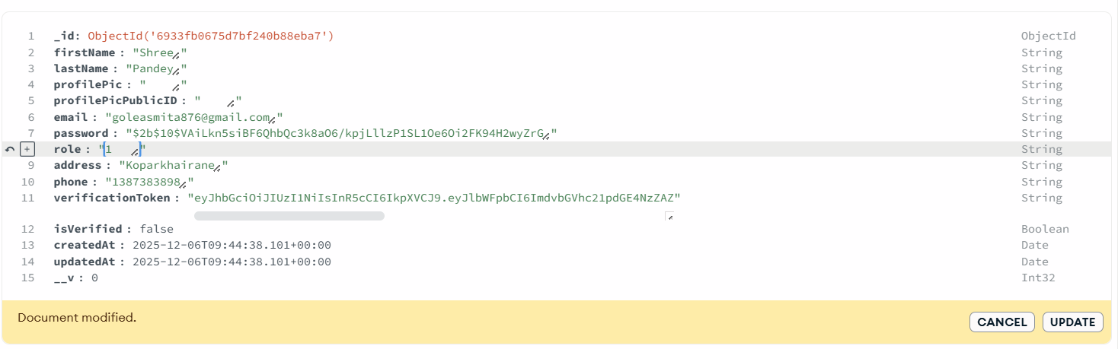
Following is the final structure of the backend
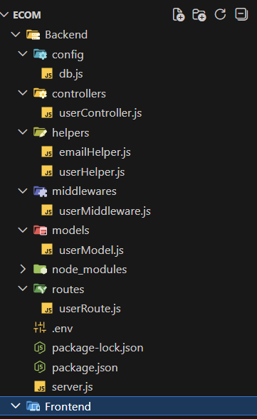
For frontend
in frontend folder create react application
1st step: for installation
Command: npm create vite@latest
It will create one react vite app
Packages :
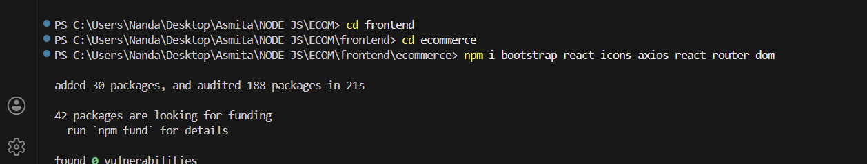

For backend and frontend connection on one command we can use the concurrently package and if occurs any errors or issues in connection we can use cors let’s see how this works
Firstly in backend install the packages like concurrently and cors both . Then in backend server.js file import the cors and used it
e.g.
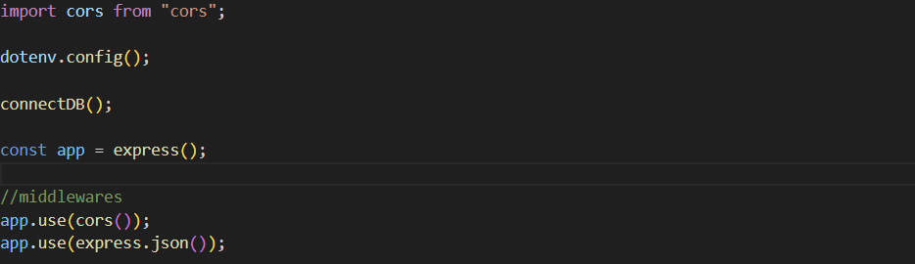

Then in backend package.json add scripts like:
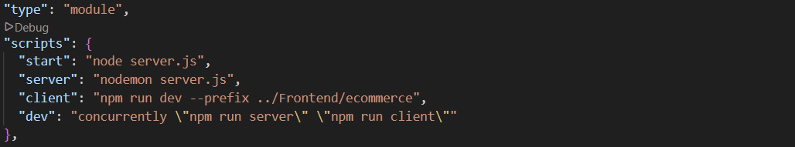

Next step in src folder create one folder as a pages in you can continue your common files like Home.jsx , About.jsx and more in pages folder create one Auth folder in that create 2 files Register.jsx and Login.jsx
Register.jsx:

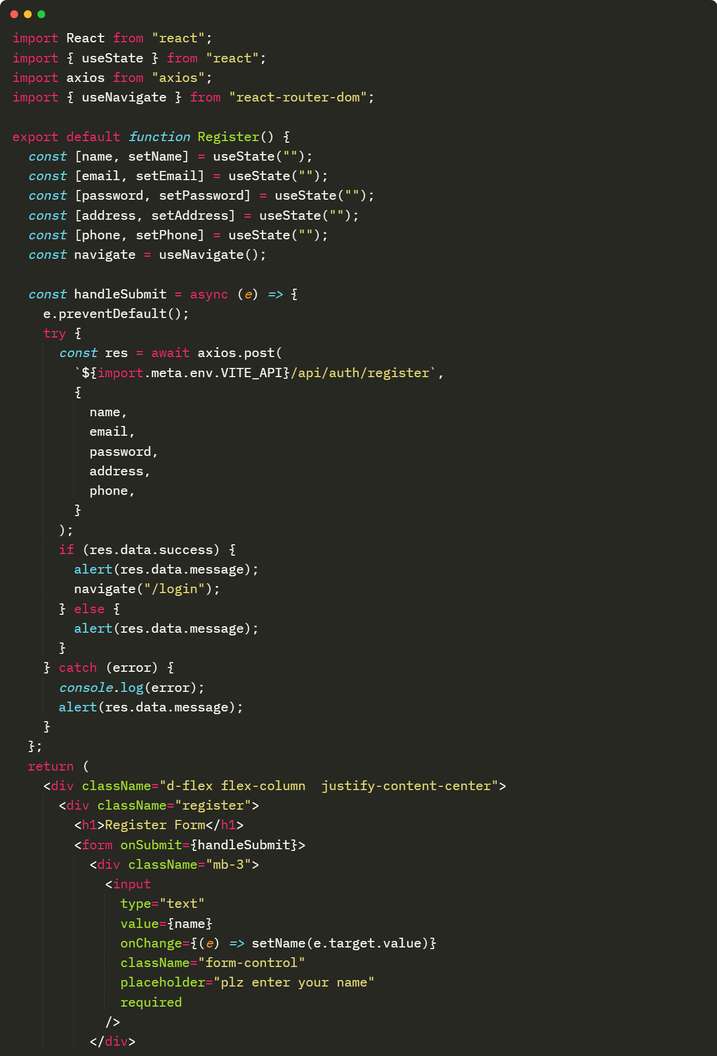

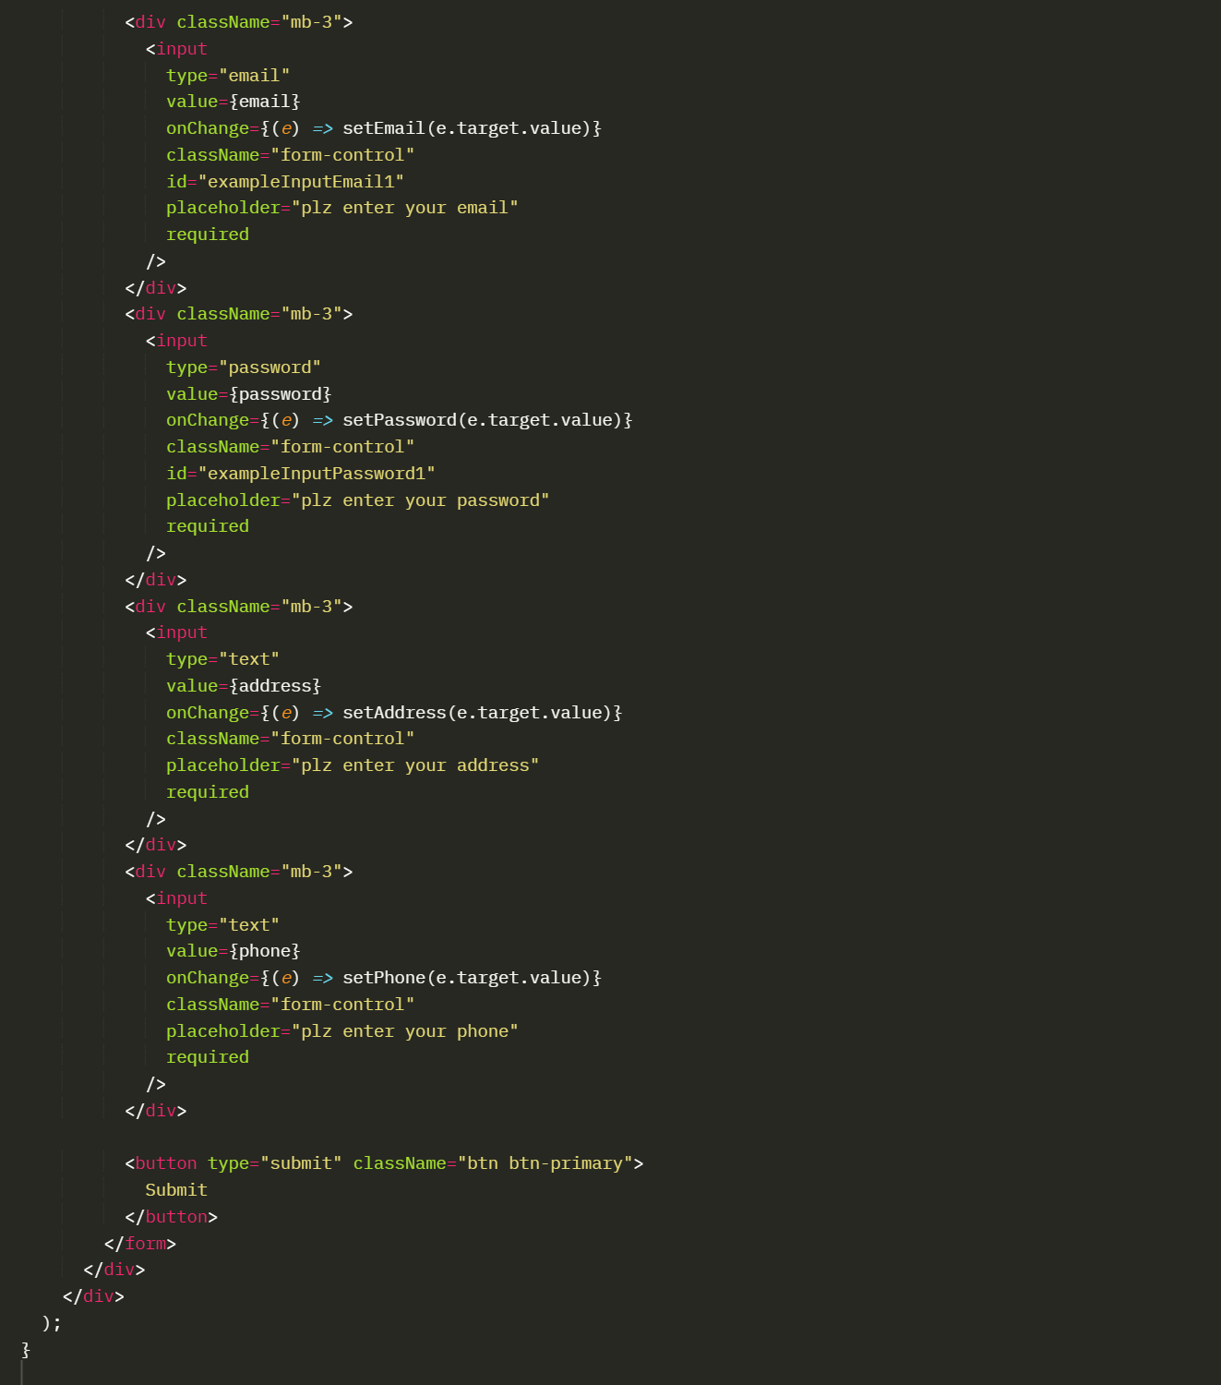

Login.jsx:

